**Kunal Singh (1600116C202)**

**KANTI SUDHA (1600240C203)**

**SECTION: D**

Abstract

This report the design and modelling of a ceiling fan ,using Siemen’s NX software.

NX PROJECT

CEILING FAN

**MODEL AFTER FINAL ASSEMBLY:-**

**(File name final.prt)**

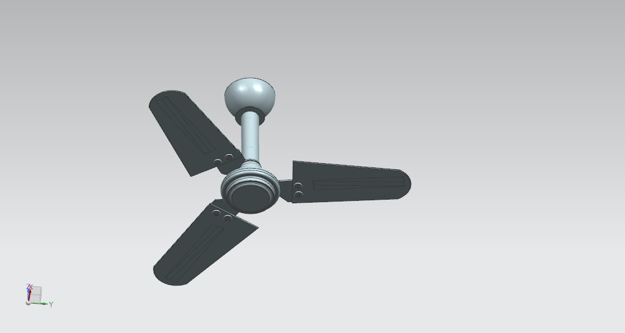

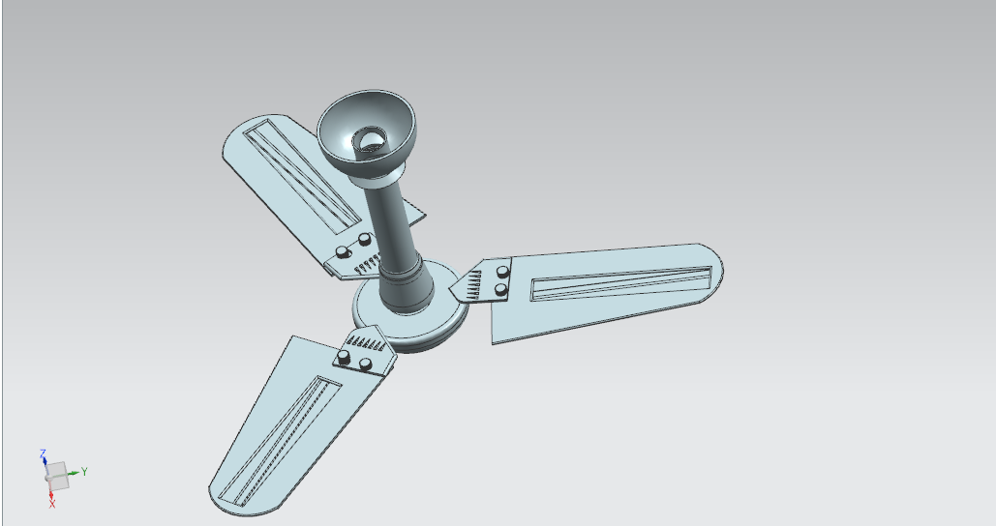

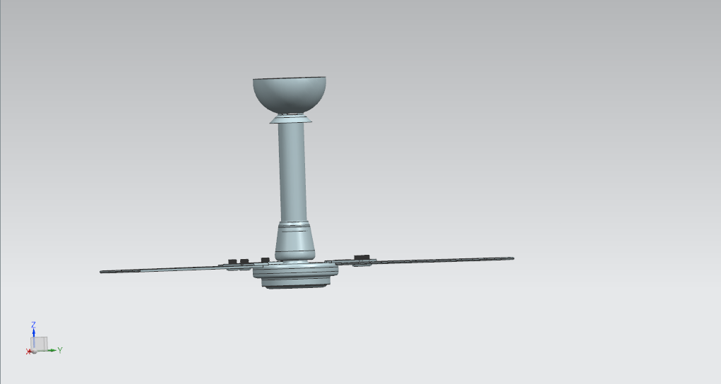

**THE FINAL MODEL ASSEMBLY HIEARACHY WILL LOOK LIKE :-**

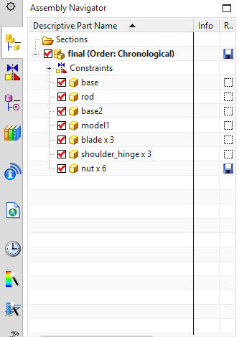

**THE MODEL IN EXPLODED VIEW:-**

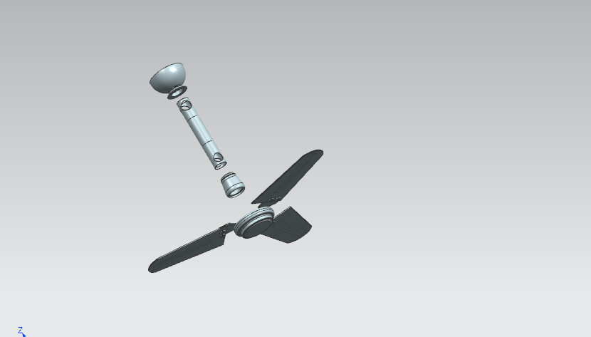

**The assembly consists of all the visual parts of the fan including the blade nuts base motor rod and the plastic cup.**

**The assembly hierarchy of the model can be seen in the image above. The above image will give a fair idea of the way the model is assembled.**

**THE VARIOUS PARTS :-**

1. **Base plastic cup:-**

**(file name base.prt)**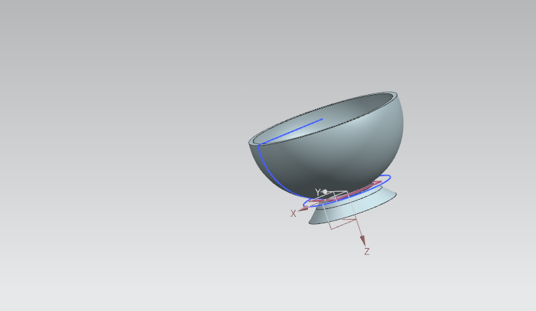

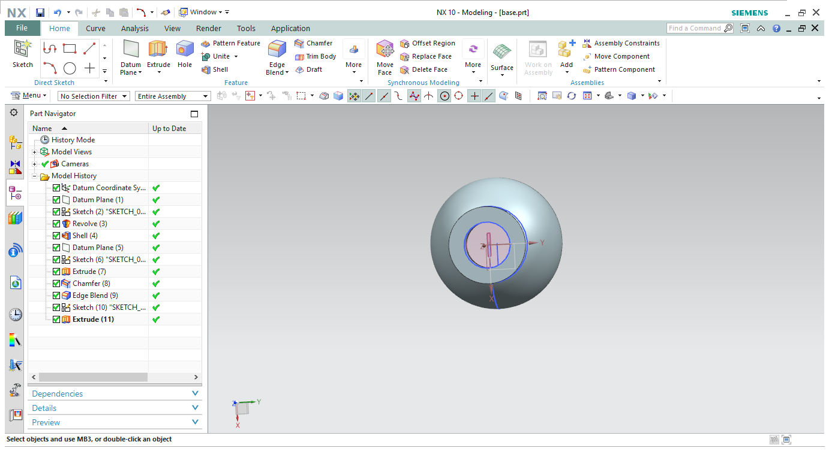

**THE CONSTRUCTION HISTORY :-**

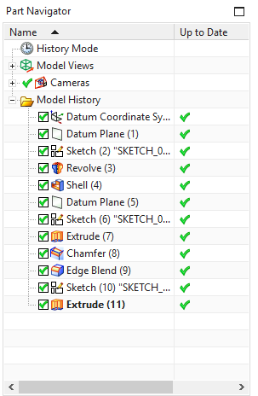

**The shape was first drawn using a curve sketch and then revolved to give the shape. Further extrude and edge blend commands were given to refine the design.**

1. **The second plastic cup:-**

**(file name base2.prt)**

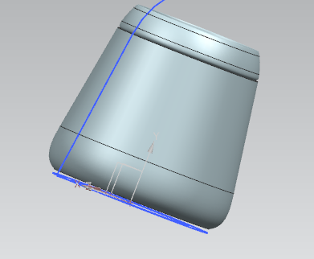

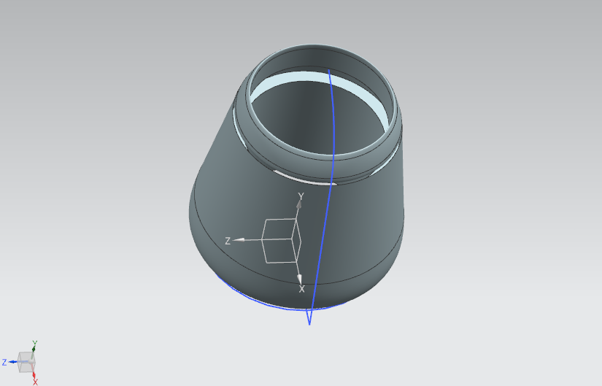

**The construction history :-**

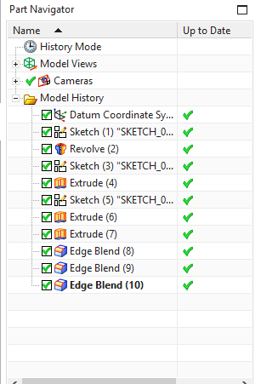

**This tool was first sketched using the curve tool and then revolved to give the shape. Then multiple extrudes and edge blends commands were given to give the shape of the object. The holes were created by using the subtract Boolean inside of the body by drawing another sketch on the surface.**

**3.Rod**

**(file name rod.prt)**

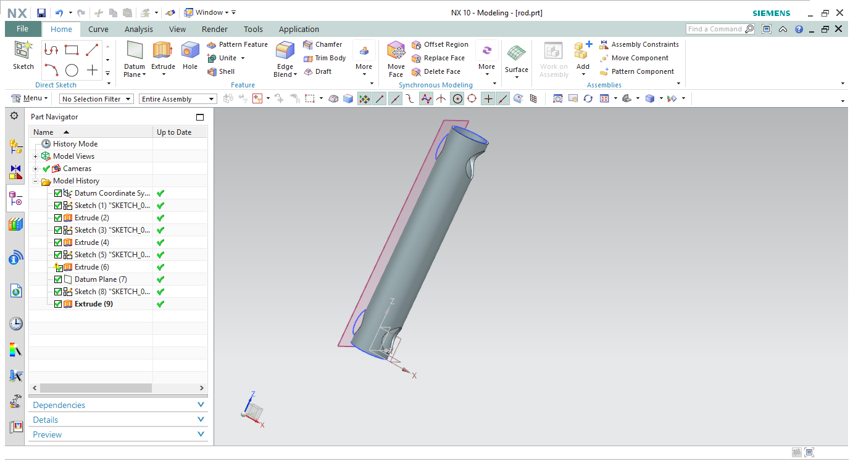

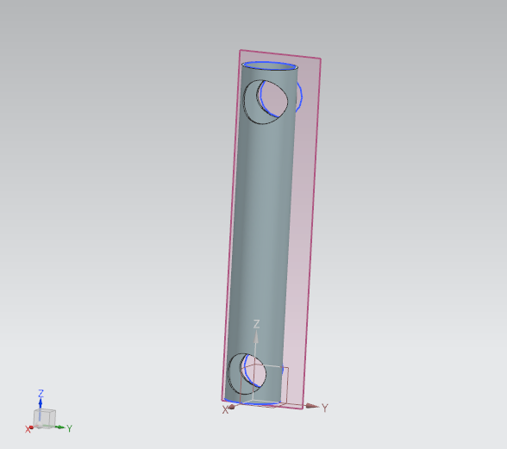

**The construction history:-**

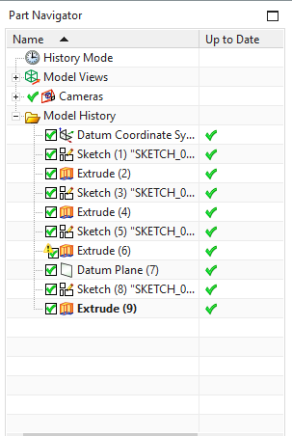

**The object was first sketched using the circle and then extruded. The holes were created using a subtract Boolean by drawing to other circles on the surface and then extruding them inside the body.**

**4.Nut**

**(file name nut.prt)**

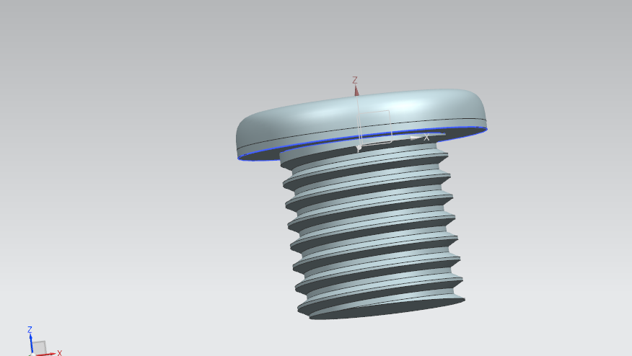

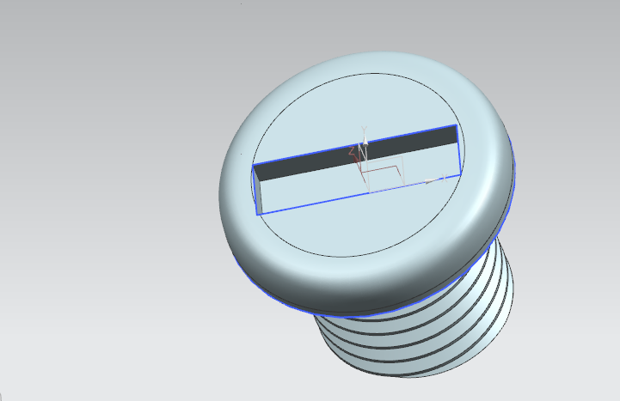

**Construction history:-**

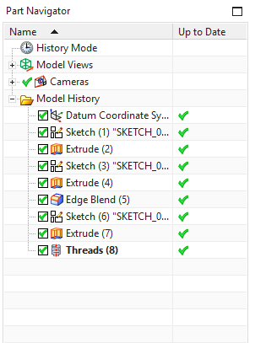

**A big circle was sketched and extruded and then at the bottom another sketch was drawn and extruded using the unite Boolean.**

**The threading command was used.**

**To give the surface of the screw head a rounded feel the edge blend was used and the area for the screw driver to be held was created using a subtract Boolean.**

**5.Base Motor:-**

**(file name model1.prt)**

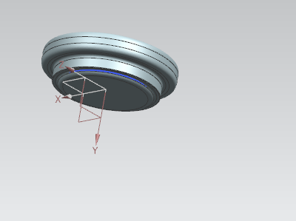

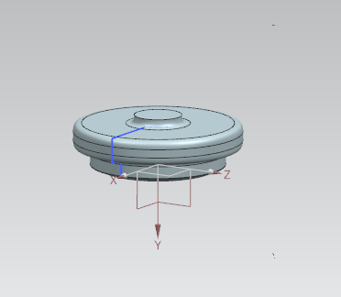

**The Construction history:-**

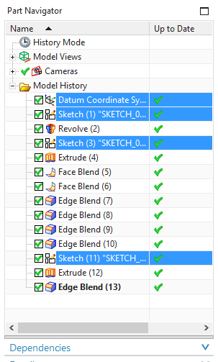

**This piece was simply using the curve sketch which we revolved in order to get the shape of the base motor of the fan. We then created multiple sub sketches on the surface to give detail to the model.**

**6. Blade:-**

**(file name blade.prt)**

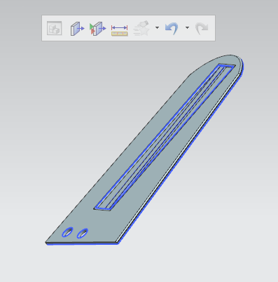

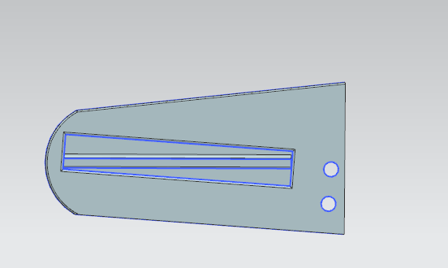

**The construction history:-**

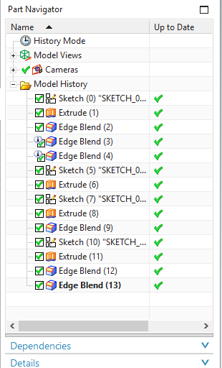

**For this piece we simply created a simple sketch using curves and arcs and then extruded the model. All the detail in the model is added using sub sketches and then extruding them. The edge bled command was also used.**

**7.Shoulder hinge:-**

**(file name shoulder_hinge.prt)**

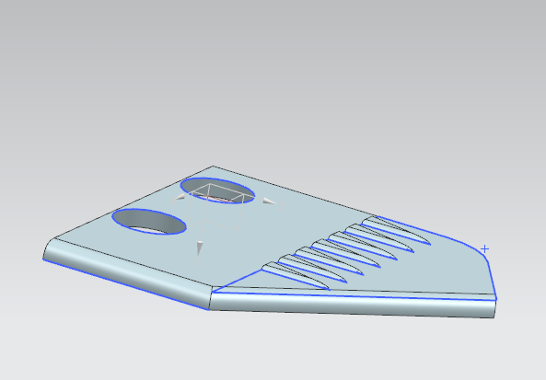

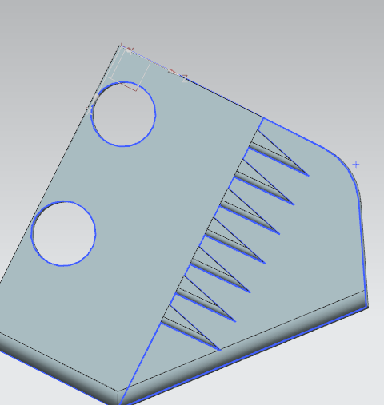

**The construction history:-**

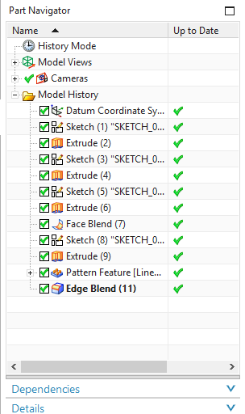

**This object profile is created using curves. These curves are then extruded and then using the subtract Boolean two holes are created on the hinge. For the purpose of design a raised surface was created and using the pattern feature command the pattern was repeated on the surface of the shoulder hinge.**